COURSE NAME: Theory of Computation COURSE CODE: CSA1304

COURSE OUTCOME COVERED

CO4: Construct Context-Free Grammars, generate derivations and parse trees to demonstrate the syntactic structure of strings. (BL : 3)

Assessment Tool Weightage: 40%

QUESTIONS: 5 Total Marks:100
Duration : 1 Hour

CLASS TEST

Code of Conduct:

I SRIVARSHA M - 192371010(Name / Reg No) certify that this submission is my original work and that I have adhered to the guidelines specified for this assessment.
I understand that any violation of academic integrity rules will result in disciplinary action.

Signature of the student:
SRIVARSHA M
- Design a PDA to accept strings with 'n' occurrences of 'a' followed by 'n' occurrences of 'b', where 'n' is a non-negative integer.
  - L = {an bn}

- Convert the given context-free grammar (CFG) into a Pushdown Automaton (PDA) that recognizes the same language.
E → E+E | E*E | (E) | I I → Ia | Ib | I0 | I1 | a | b

- Design a TM to accepts the strings with 'n' occurrences of 'a' followed by 'n' occurrences of 'b', where 'n' is a non-negative integer
  - L = {0n1n | n ≥ 1}

- Design a Pushdown Automata for the language representing a’s followed by b’s and the number of b’s must be twice than that of a’s.
𝐿 = {𝑎^{𝑛}𝑏^{2𝑛} | 𝑛 ≥ 1}
- Construct a Turing Machine to recognize the language. Write the logic used for the design and the formal definition
𝐿 = {𝑎^{𝑛}𝑏^{𝑛}𝑐^{𝑛} | 𝑛 ≥ 1}

Question 1 — PDA for L = {aⁿbⁿ | n ≥ 0}
Design a PDA to accept strings with 'n' occurrences of 'a' followed by 'n' occurrences of 'b'.

Logic
Every 'a' read is pushed onto the stack. Once the input switches to 'b', each 'b' pops one 'a' from the stack. If the stack returns to just the bottom marker Z0 exactly when the input ends, the number of a's equalled the number of b's, so the string is accepted.

Formal Definition
M = (Q, Σ, Γ, δ, q0, Z0, F)
Q = {q0, q1, q2}
Σ = {a, b}
Γ = {a, Z0} (stack alphabet; write 'A' for pushed a's)
q0 = initial state, Z0 = initial stack symbol
F = {q0, q2} (q0 accepts n = 0, q2 accepts n ≥ 1)

Transition Function δ
Current State | Input | Stack Top | Next State | Stack Action
q0 | a | Z0 | q0 | push A → A Z0
q0 | a | A | q0 | push A → A A
q0 | b | A | q1 | pop A → ε
q1 | b | A | q1 | pop A → ε
q1 | ε | Z0 | q2 | no change (accept)
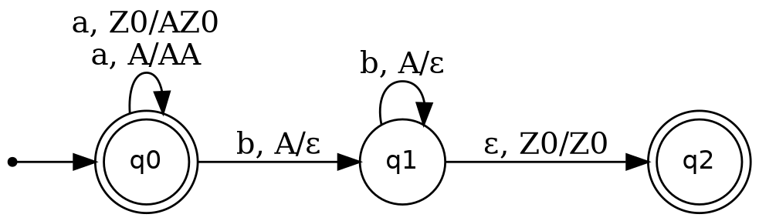
Fig. 1.1 — State transition diagram of the PDA for {aⁿbⁿ | n ≥ 0}

Trace for input 'aabb'
Step | State | Remaining Input | Stack (top→bottom)
0 | q0 | aabb | Z0
1 | q0 | abb | A Z0
2 | q0 | bb | A A Z0
3 | q1 | b | A Z0
4 | q1 | ε | Z0
5 | q2 (accept) | ε | Z0

Question 2 — CFG to PDA Conversion
Convert the given CFG into a PDA that recognizes the same language.
E → E+E | E*E | (E) | I
I → Ia | Ib | I0 | I1 | a | b

Logic (Standard Top-Down / Leftmost-Derivation Construction)
• Push the start symbol E on the stack together with a bottom marker $.
• Whenever a variable (E or I) is on top of the stack, non-deterministically replace it with the right-hand side of one of its productions (an ε-move).
• Whenever a terminal is on top of the stack and it matches the next input symbol, pop it and consume that input symbol.
• When only the bottom marker $ is left on the stack and the entire input has been read, accept.
This single-state-loop PDA effectively simulates a leftmost derivation of the grammar on its stack.

Formal Definition
M = ({q0, q1, q2}, Σ, Γ, δ, q0, $, {q2})
Σ = {a, b, 0, 1, +, *, ( , )}
Γ = {E, I, a, b, 0, 1, +, *, ( , ), $}

Transition Function δ
Current State | Input | Stack Top | Next State | Stack Action
q0 | ε | ε | q1 | push → E $
q1 | ε | E | q1 | replace → E+E
q1 | ε | E | q1 | replace → E*E
q1 | ε | E | q1 | replace → (E)
q1 | ε | E | q1 | replace → I
q1 | ε | I | q1 | replace → Ia
q1 | ε | I | q1 | replace → Ib
q1 | ε | I | q1 | replace → I0
q1 | ε | I | q1 | replace → I1
q1 | ε | I | q1 | replace → a
q1 | ε | I | q1 | replace → b
q1 | t ∈ Σ | t | q1 | pop → ε (match & consume terminal)
q1 | ε | $ | q2 | accept
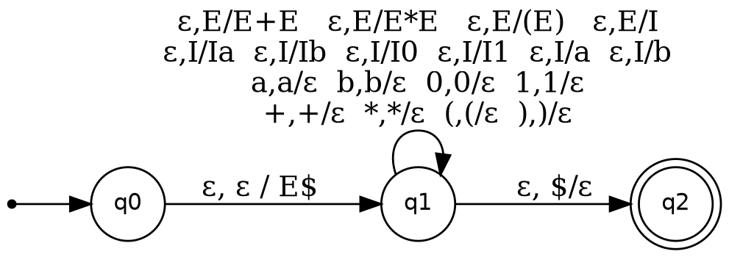
Fig. 2.1 — State transition diagram of the PDA obtained from the CFG

Sample Trace for the string 'a+b' (via E → E+E → I+E → a+E → a+I → a+b)
Step | Stack (top→bottom) | Action
1 | E $ | push start symbol
2 | E+E $ | E → E+E
3 | I+E $ | E → I (leftmost E)
4 | a+E $ | I → a
5 | +E $ | match input 'a', pop
6 | E $ | match input '+', pop
7 | I $ | E → I
8 | b $ | I → b
9 | $ | match input 'b', pop
10 | ε → accept | stack shows only $, input exhausted

Question 3 — TM for L = {0ⁿ1ⁿ | n ≥ 1}
Design a TM that accepts strings with n occurrences of 0 followed by n occurrences of 1.

Logic
• Cross off (mark) the leftmost unmarked 0 by writing X, then move right to find and mark the leftmost unmarked 1 by writing Y.
• Return to the left end of the tape and repeat the process for the next unmarked 0 / 1 pair.
• When no unmarked 0's remain, sweep right; if only Y's are found before the blank, every 1 was matched — accept. If a stray 0 or 1 is found, reject.
• Since q1 has no transition defined on blank (⊔), the empty string is rejected — matching the requirement n ≥ 1.

Formal Definition
M = (Q, Σ, Γ, δ, q1, ⊔, F)
Q = {q1, q2, q3, q4, q5}
Σ = {0, 1}
Γ = {0, 1, X, Y, ⊔}
F = {q5}

Transition Function δ (read → write, move, next state)
State | 0 | 1 | X | Y | ⊔
q1 | X,R,q2 | — | — | Y,R,q4 | —
q2 | 0,R,q2 | Y,L,q3 | — | Y,R,q2 | —
q3 | 0,L,q3 | — | X,R,q1 | Y,L,q3 | —
q4 | — | — | — | Y,R,q4 | ⊔,R,q5 (accept)
q5 (accept) | — | — | — | — | —
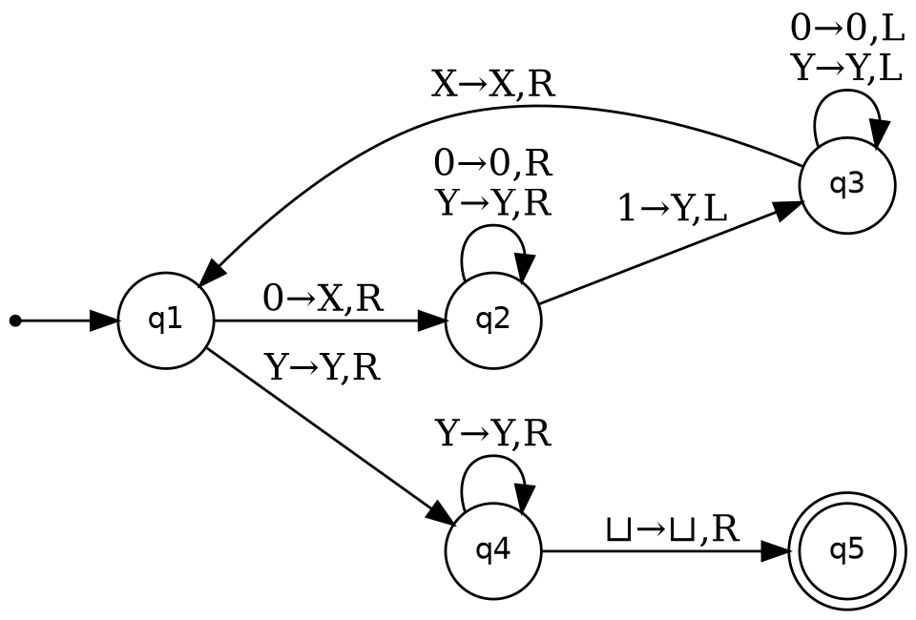
Fig. 3.1 — State transition diagram of the TM for {0ⁿ1ⁿ | n ≥ 1}

Trace for input '0011'
q1 0011 ⊢ X q2 011 ⊢ X0 q2 11 ⊢ X q3 0Y1 ⊢ q3 X0Y1
⊢ X q1 0Y1 ⊢ XX q2 Y1 ⊢ XXY q2 1 ⊢ XX q3 YY
⊢ X q3 XYY ⊢ XX q1 YY ⊢ XXY q4 Y ⊢ XXYY q4 ⊔ ⊢ XXYY⊔ q5 (ACCEPT)

Question 4 — PDA for L = {aⁿb²ⁿ | n ≥ 1}
Design a PDA for a's followed by b's, where the number of b's is twice the number of a's.

Logic
Push one symbol A for every 'a' read. Each 'a' must be cancelled by exactly two b's, so the b's are consumed two at a time: the first 'b' of a pair only changes state (no pop), and the second 'b' of the pair pops one A. This alternation, controlled by states q1 (odd b) and q2 (even b), guarantees that popping the stack empty requires exactly twice as many b's as a's.

Formal Definition
M = ({q0, q1, q2, q3}, {a, b}, {A, Z0}, δ, q0, Z0, {q3})

Transition Function δ
Current State | Input | Stack Top | Next State | Stack Action
q0 | a | Z0 | q0 | push A → A Z0
q0 | a | A | q0 | push A → A A
q0 | b | A | q1 | no change (1st b of pair)
q1 | b | A | q2 | pop A → ε (2nd b of pair)
q2 | b | A | q1 | no change (next 1st b of pair)
q2 | ε | Z0 | q3 | no change (accept)
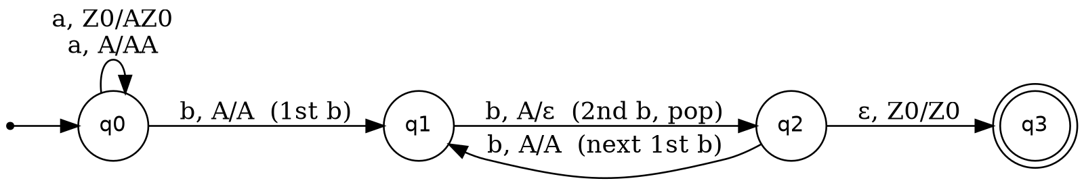
Fig. 4.1 — State transition diagram of the PDA for {aⁿb²ⁿ | n ≥ 1}

Trace for input 'aabbbb'
Step | State | Remaining Input | Stack (top→bottom)
0 | q0 | aabbbb | Z0
1 | q0 | abbbb | A Z0
2 | q0 | bbbb | A A Z0
3 | q1 | bbb | A A Z0
4 | q2 | bb | A Z0
5 | q1 | b | A Z0
6 | q2 | ε | Z0
7 | q3 (accept) | ε | Z0

Question 5 — TM for L = {aⁿbⁿcⁿ | n ≥ 1}
Construct a TM to recognize the language, with logic used for the design and formal definition.

Logic
• Scan for the leftmost unmarked 'a' and mark it X, then move right, skipping marked a's, to find the leftmost unmarked 'b' and mark it Y.
• Continue right, skipping marked b's, to find the leftmost unmarked 'c' and mark it Z, then return the head all the way to the left end of the tape.
• Repeat this cycle for the next unmarked a / b / c triple.
• Once no unmarked a's remain, sweep right through the Y's and Z's; if the tape ends in blank with none left over (no stray b or c), accept.
• Since q0 has no transition on blank, the empty string is rejected, satisfying n ≥ 1.

Formal Definition
M = (Q, Σ, Γ, δ, q0, ⊔, F)
Q = {q0, q1, q2, q3, q4}
Σ = {a, b, c}
Γ = {a, b, c, X, Y, Z, ⊔}
F = {q4}

Transition Function δ (read → write, move, next state)
State | a | b | c | X | Y | Z | ⊔
q0 | X,R,q1 | — | — | — | Y,R,q4 | — | —
q1 | a,R,q1 | Y,R,q2 | — | — | Y,R,q1 | — | —
q2 | — | b,R,q2 | Z,L,q3 | — | — | Z,R,q2 | —
q3 | a,L,q3 | b,L,q3 | c,L,q3 | X,L,q3 | Y,L,q3 | Z,L,q3 | ⊔,R,q0
q4 (accept) | — | — | — | — | Y,R,q4 | Z,R,q4 | accept
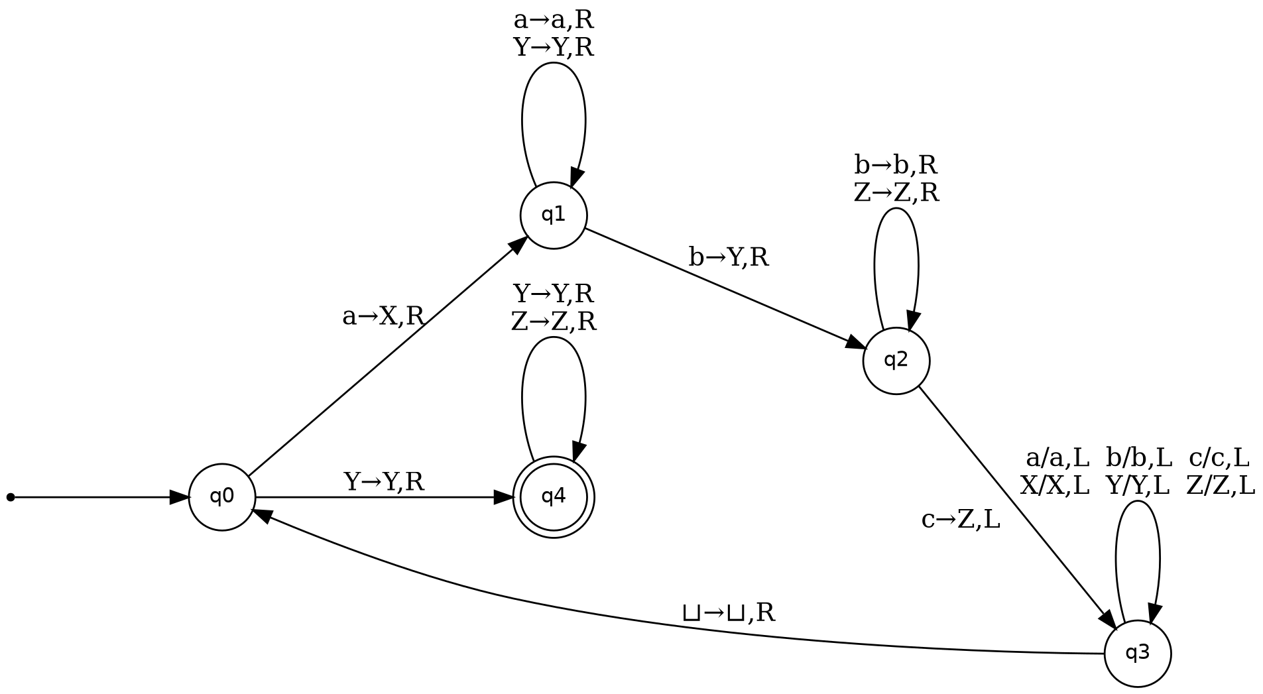
Fig. 5.1 — State transition diagram of the TM for {aⁿbⁿcⁿ | n ≥ 1}

Trace for input 'aabbcc'
q0 aabbcc ⊢ X q1 abbcc ⊢ Xa q1 bbcc ⊢ XaY q2 bcc
⊢ XaYb q2 cc ⊢ XaY q3 bZc ⊢ Xa q3 YbZc ⊢ X q3 aYbZc
⊢ q3 XaYbZc ⊢ X q0 aYbZc ⊢ XX q1 YbZc ⊢ XXY q1 bZc
⊢ XXYY q2 Zc ⊢ XXYYZ q2 c ⊢ XXYY q3 ZZ ⊢ XXY q3 YZZ
⊢ XX q3 YYZZ ⊢ X q3 XYYZZ ⊢ q3 XXYYZZ ⊢ X q0 XYYZZ
⊢ XX q0 YYZZ ⊢ XXY q4 YZZ ⊢ XXYY q4 ZZ ⊢ XXYYZ q4 Z
⊢ XXYYZZ q4 ⊔ (ACCEPT)

RUBRICS FOR CALCULATION

Criteria | Weightage | Level 4 –  Exemplary (5 Marks) | Level 3 –  Proficient (4 Marks) | Level 2 –  Developing (2–3 Marks) | Level 1 – Beginning  (0–1 Mark)
Conceptual Understandin g | 30 | Demonstrates clear and complete understanding of  the concept | Good understanding with minor gaps | Basic understanding with some misconceptions | Poor or incorrect understandin g
Accuracy of Answer | 25 | Completely correct answer  with no errors | Mostly correct with minor  errors | Partially correct with noticeable  errors | Incorrect or irrelevant  answer
Application of Knowledge | 20 | Correctly applies concepts to solve the  question/problem | Applies concepts with minor mistakes | Limited or partially correct application | No or incorrect application
Completeness of Response | 15 | Covers all required parts of the question | Covers most parts with minor  omissions | Covers only some parts | Incomplete or missing response
Clarity & Presentation | 10 | Clear, concise, and well-  organized answer | Understandabl e with minor  issues | Somewhat unclear or poorly  structured | Difficult to understand

